A000-AM,C-Taino-Duho-lignum vitae-1000 CE

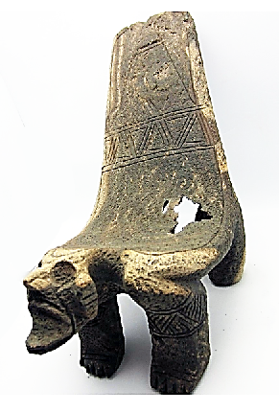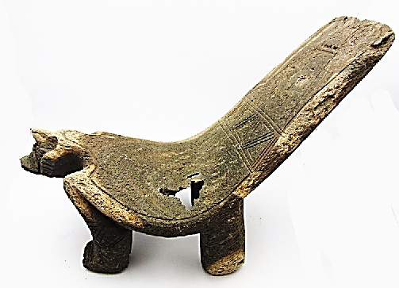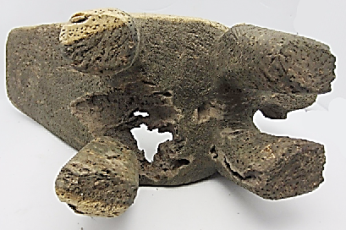

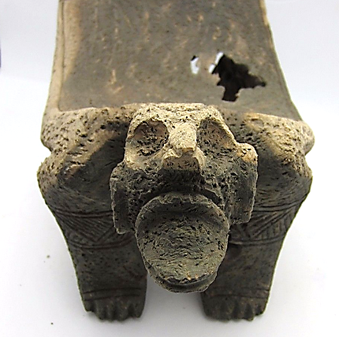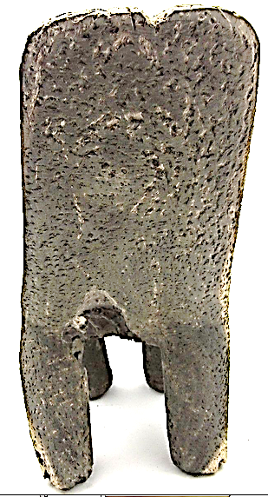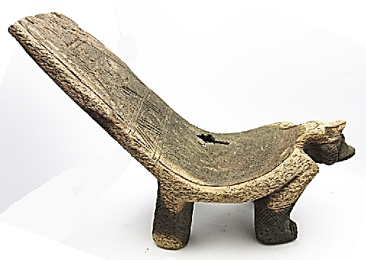

Case No. 18

Accession No.:

**Formal Label: Taino wooden *Duho***

**Display Description:** *Duho*s are carved wooden or stone ceremonial stools found in the houses of Taino caciques or chiefs throughout the Caribbean region. The Duhos are carved from a tropical hardwood called guayacan (*Guaiacum officinale* L.). The surface of the sculptures were probably polished with pebbles to bring the resin to the surface and attain a black luster. Caciques of each village would watch the game of *Batu,* while sitting on their *Duhos*, which often had spiritual images carved at its front, such as this *Duho*, which has the image of Guayaba, lord of Coabey, the underworld, where the ancestral dead resided. *Duhos* literally symbolized the seat of Taino political and ideological power. *Duhos* made of wood tend not to last in the Caribbean environment and are, therefore, much rarer than those made of stone. This Duho has inscribed on its back two double lines which separate the three levels of the Taino cosmos.

**Accession Number:**

**LC Classification:** F 1909

**Date or Time Horizon:** 1157-1131 (Calibrated radiocarbon dates)

**Geographical Area: Puerto Rico, Caribbean**

**LC Classification: F 1909**

**Date or Time Horizon: 1000 CE**

**Geographical Area:** From the Dominican Republic, i.e., Eastern Hispaniola

**Map:**

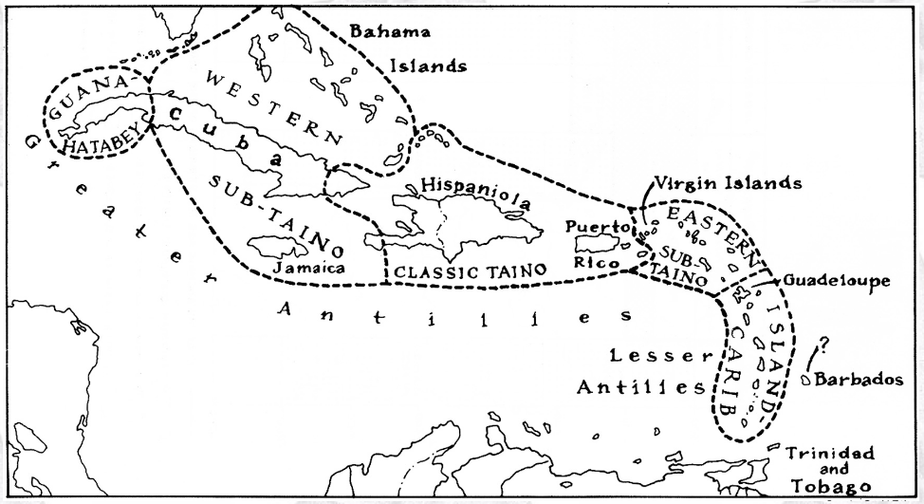

**Caribbean c 1500 after http://www.latinamericanstudies.org/maps/Ciboney-Taino-Carib-**

**GPS coordinates: Cultural Affiliation: Classic Taino**

**Cultural Affiliation:** Taino

**Medium:** lignum vitae wood, ***Guaiacum sanctum***, commonly known as **Holywood Lignum-vitae**, is a species of the creosote bush family, Zygophyllaceae. It ranges from southern Florida and the Bahamas south to the Greater Antilles. This tree is slow growing, reaching about 7 m (23 ft) in height with a trunk diameter of 50 cm (20 in). It has medicinal properties.

**Dimensions:** L 13 in W 5 in, H 9.5.  **Weight: 3 lbs.**

**Provenance:**

**Condition: original.**

**Discussion:** The Taíno Indians, a subgroup of the Arawakan Indians (a group of American Indians in northeastern South America), inhabited the Greater Antilles (comprising Cuba, Jamaica, Hispaniola [Haiti and the Dominican Republic], and Puerto Rico) in the Caribbean Sea at the time when Christopher Columbus' arrived to the New World. Their descendants are still living there today.

**References:**

**Lyke, J.** Appendix D. Medicinal plants native to the United States: indicators of rarity and threat. 2001 (

**Núñez Meléndez, E.** Plantas medicinales de Puerto Rico: Folklore y fundamentos científicos. 1982